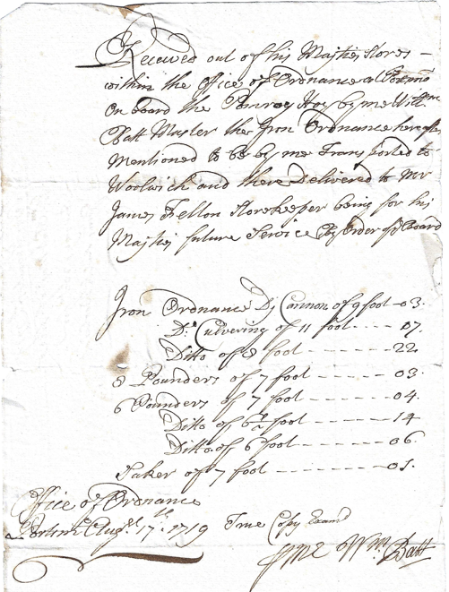

Copy August 17th 1719
W^{m} Batt Mas^{r} of the
Pomroys rec^{t} for
Guns sent to Woolwich
Received out of his Majties stores
within the Office of Ordnance at Portsmº
on Board the Pomroy Hoy by me Will^{m}
Batt Master the Iron Ordnance hereafter
mentioned to be by me Trans ported to
Woolwich and there Delivered to Mr
James Fellon Storekeeper being for his
Majties future Service by order of y^{e} Board
Iron Ordnance Di Cannon of 9 foot | 03
Dº Culvering of 11 foot | 07
Ditto of 8 foot | 22
8 Pounders of 7 foot | 03
6 Pounders of 7 foot | 04
Ditto of 6 ½ foot | 14
Ditto 6 foot | 06
Saker of 7 foot | 01
Office of Ordnance
Portsmº Aug^{st} 17th 1719 True Copy Examn^{d}
P Me W^{m} Batt

